Ha ndson 04 **-Solution**

**Create a DynamoDB database table and store items in the database**

1. Select DynamoDB from the database services section

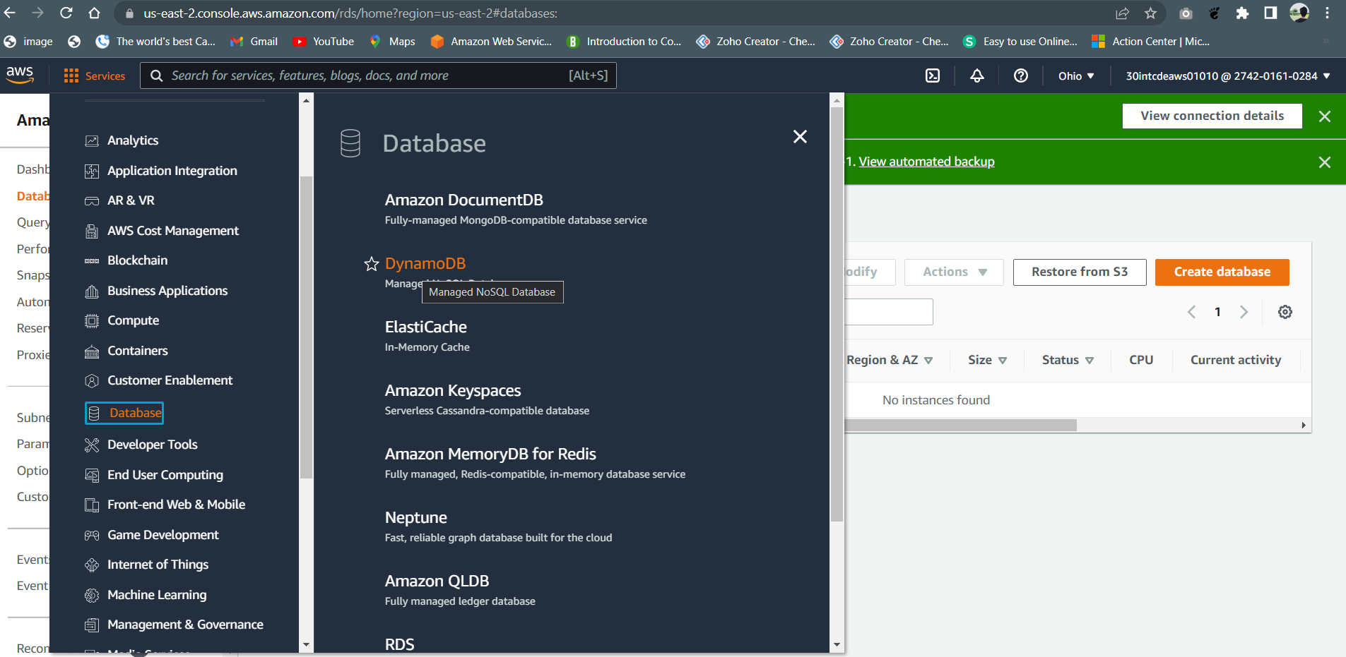

1. If there are no tables available, you will get the screen shown below.

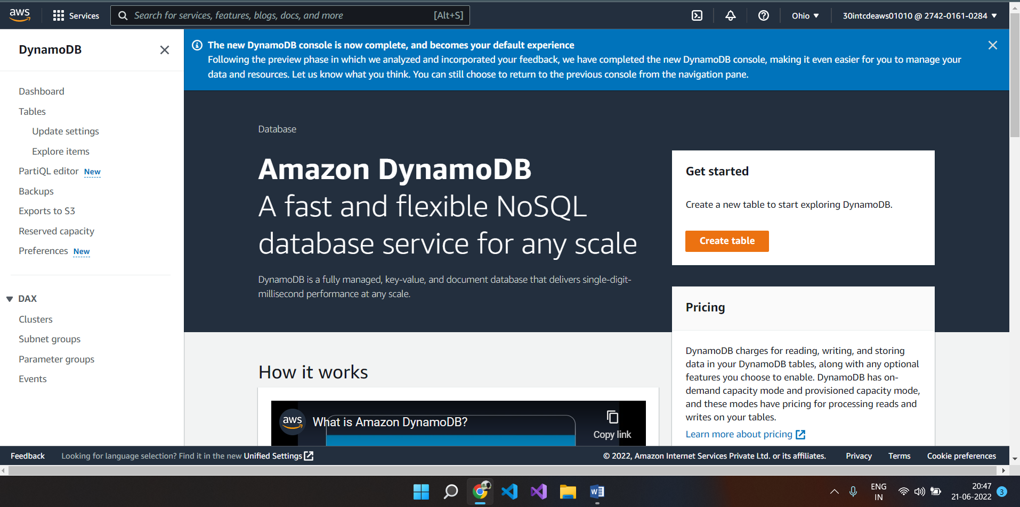

1. If there are table already created, you will get the screen shown below.

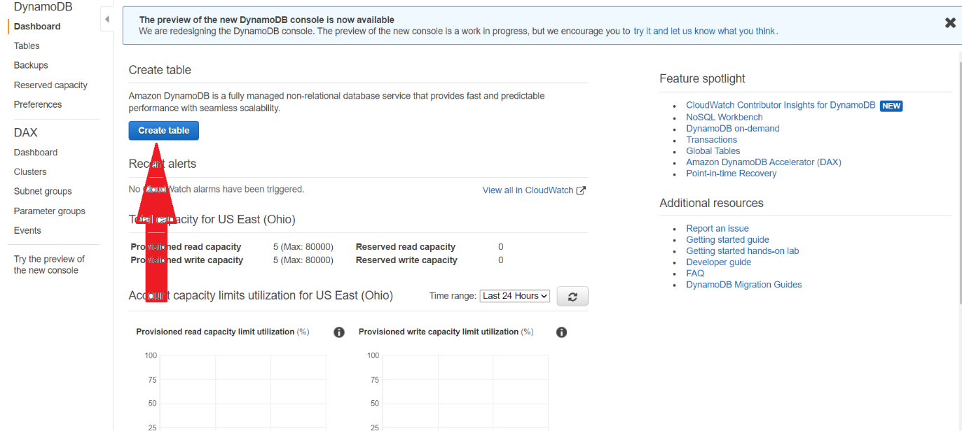

1. Click on the “Create table” button
2. Specify the table name
3. Specify the primary key and the data type
4. Specify the sort key, if required.

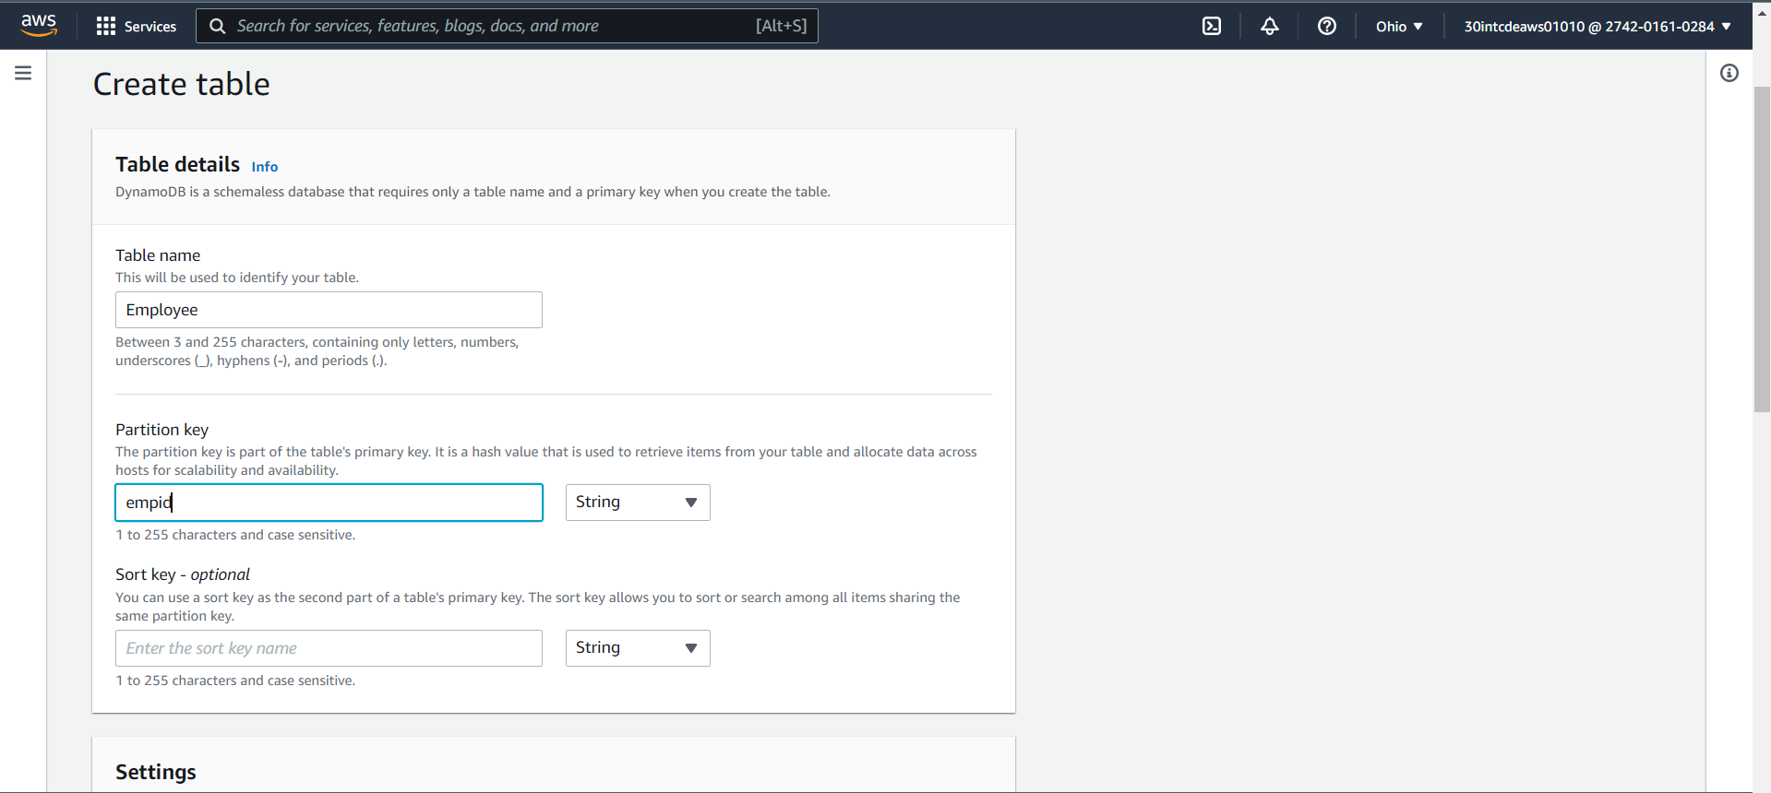

1. And click on the “Create” button
2. Once the table is created, you will get the screen shown below. Select “Explore Items” tab

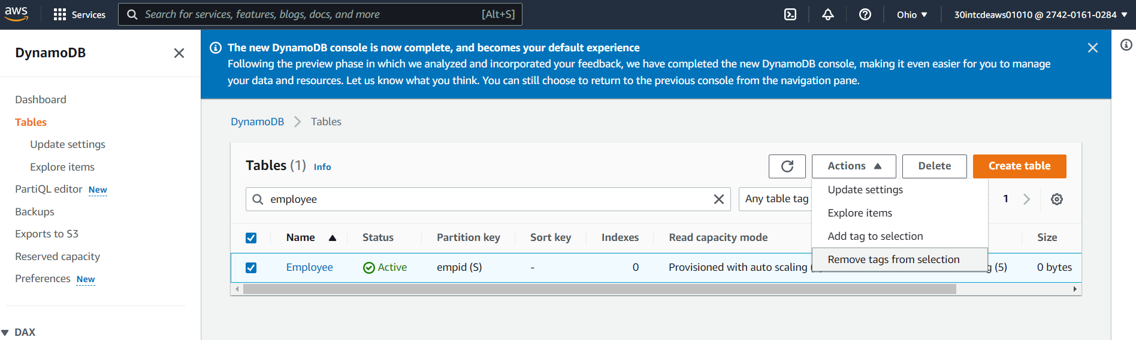

1. Click on “Create item” button

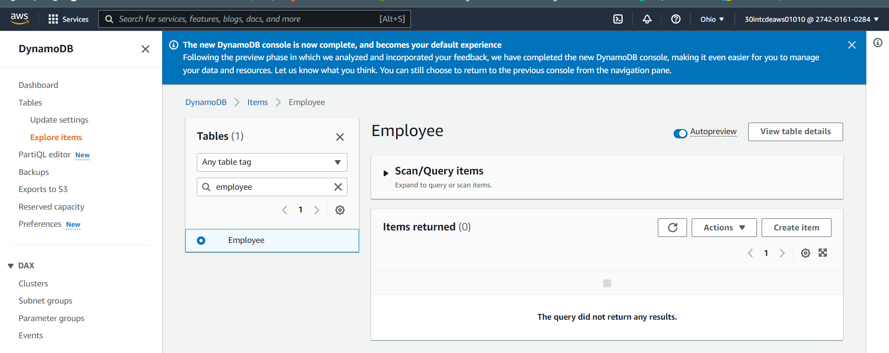

1. Click on the Add new attribute option as shown in the screen below

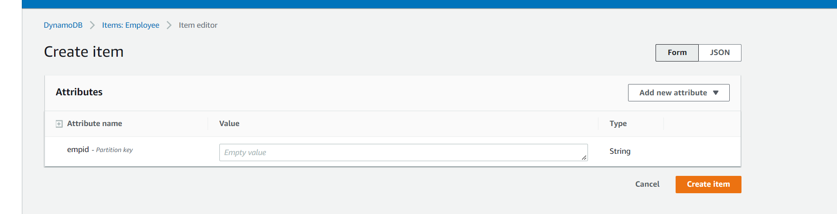

1. Select the Datatype of the attribute you are adding.

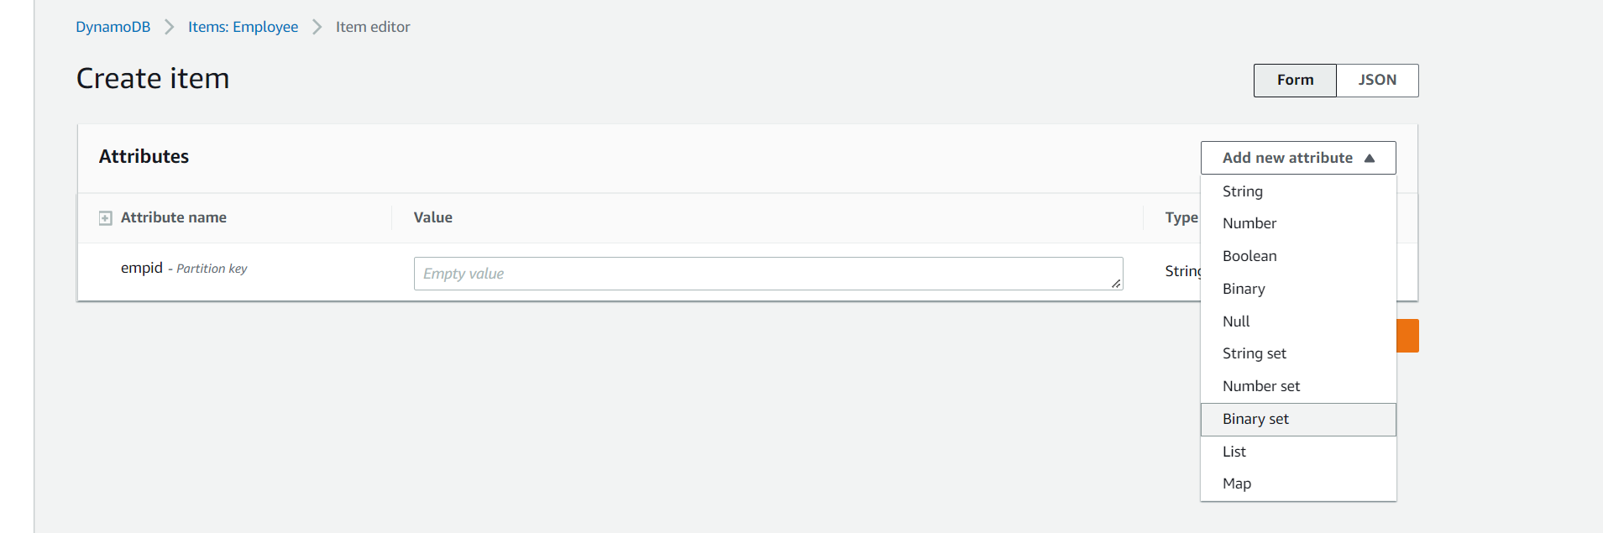

1. After adding all the required attributes and their corresponding values, click on the “Create item” button

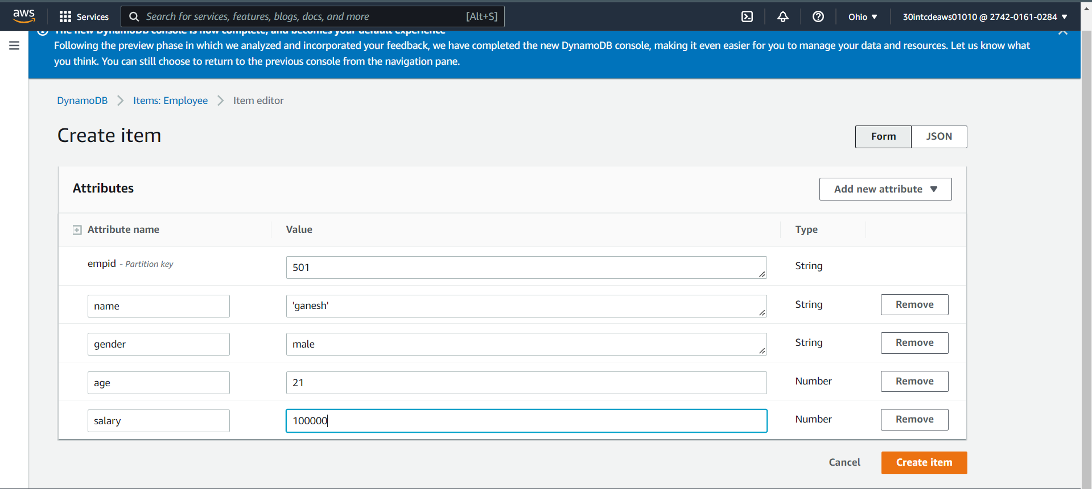

1. You will be taken back to the table screen.

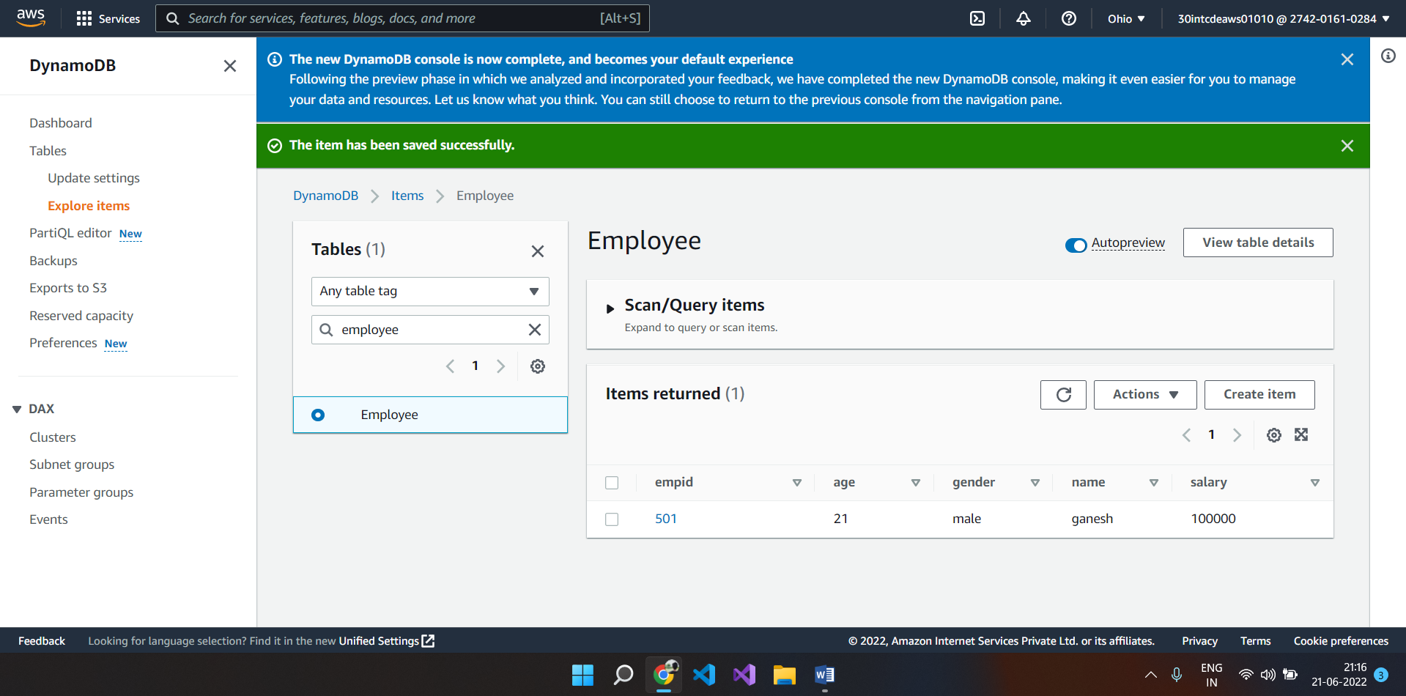

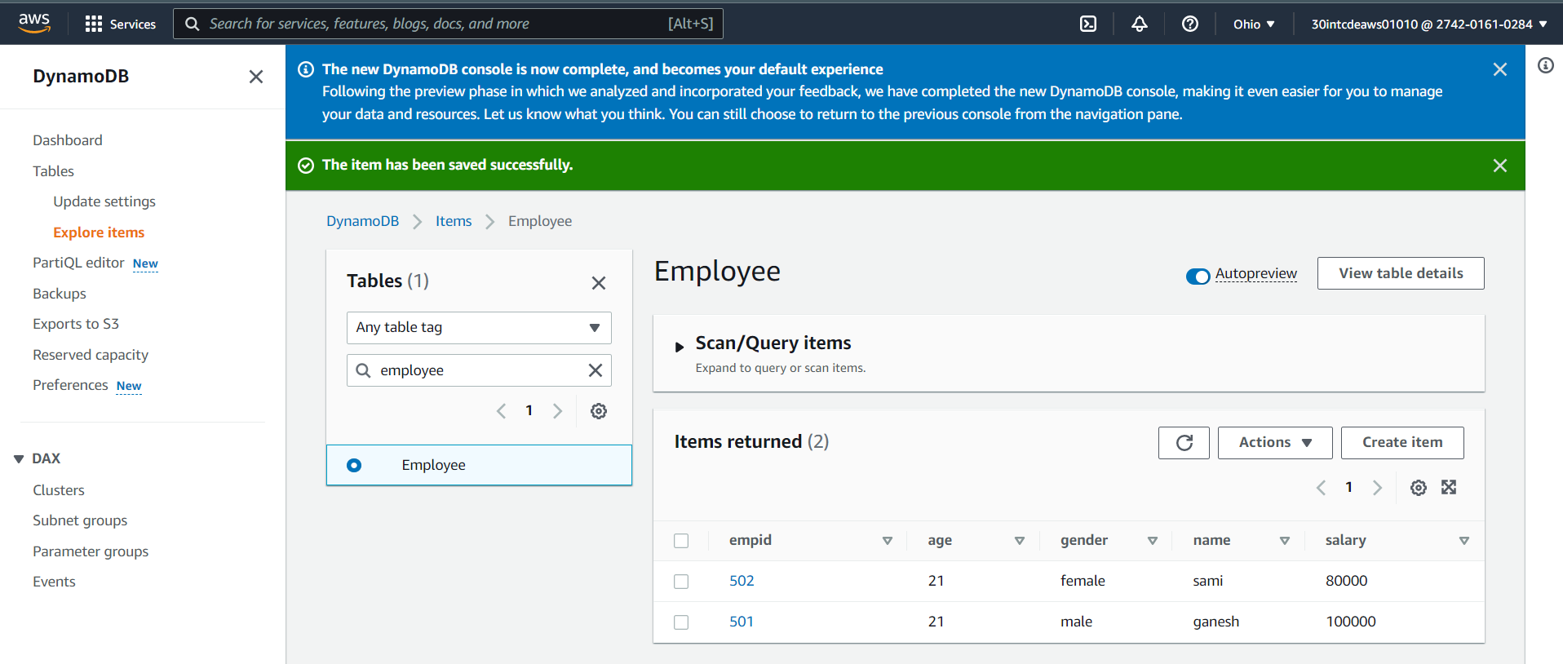

1. Once you are done, please make sure that the table is deleted by clicking on the “Delete table” button

